PHU QUOC ISLAND, VIET NAM

3D2N

OVERVIEW

## location

Phú Quốc is a Vietnamese island off the coast of Cambodia in the Gulf of Thailand. It's known for white-sand beaches and resorts, most of which are along the palm-lined southwest coast. More than half of the island is part of Phú Quốc National Park, which features mountains, dense tropical jungle, hiking trails and wildlife. Duong Dong is the largest town, with day and night markets selling crafts, produce and fish.

Area: 574 km²

Province: Kiên Giang Province

Population: 103,000 (2012)

Area code: 855

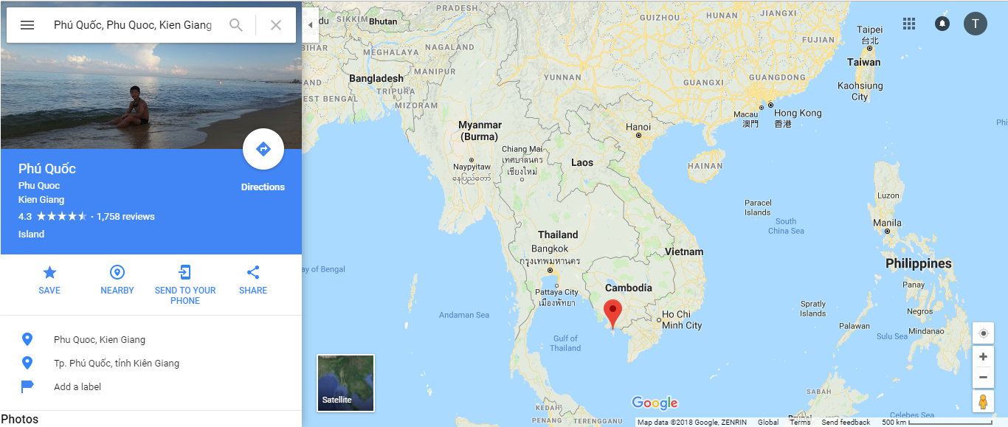

## Characteristics

A mountainous and forested island with purest beaches, fishing villages, fascinating streams, pepper gardens and fish sauce workshops; an exciting destination for scuba diving, snorkeling, angling and countryside trekking.

The island stretches out on the ocean surface as a splendid teardrop shaped pearl at 48km long, 28km across bearing over a dozen of bays and beaches with transparent turquoise waters where marine life live in abundance. The monsoon sub-equatorial climate enables trips to be made all year round, although the best time is the dry season when the sky is always sunny, clear and blue .

Phu Quoc is a real serene retreat for those who wish to put away the time in contemplation or meditation. Quite a few temples and shrines lie scattered across the island. Some worthy examples are Sung Hung Pagoda, with its original structure and intriguing statues, Su Muon Pagoda, always an inspiration for visitors thanks to its unique blend of nature and architecture.

Snorkeling service by Saigon-Phu Quoc Hotel For sports-addicted people, a host of leisure activities awaits you such as swimming, snorkeling, boating, fishing, trekking through forest park while observing exotic species of flora and fauna, or just lounging.

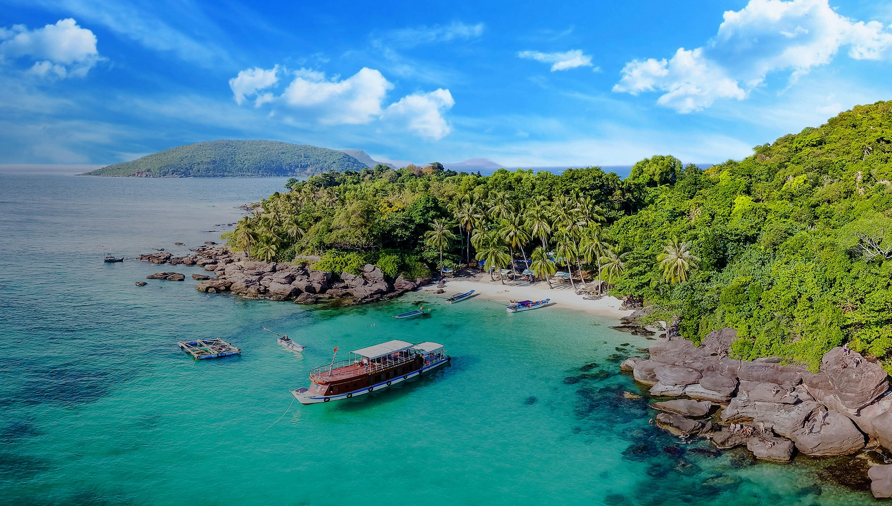

|  |  |
| --- | --- |
|  | Transfer from (Airport/Pier)by car and have an excited day with visiting |

**Arrival Phu Quoc Island**

* Suoi Tranh(waterfall for rain season only): A stroll along the shaded forest path you reach what is the islands largest string of waterfalls and rock pools, also a good place for a swim under falls are flowing.

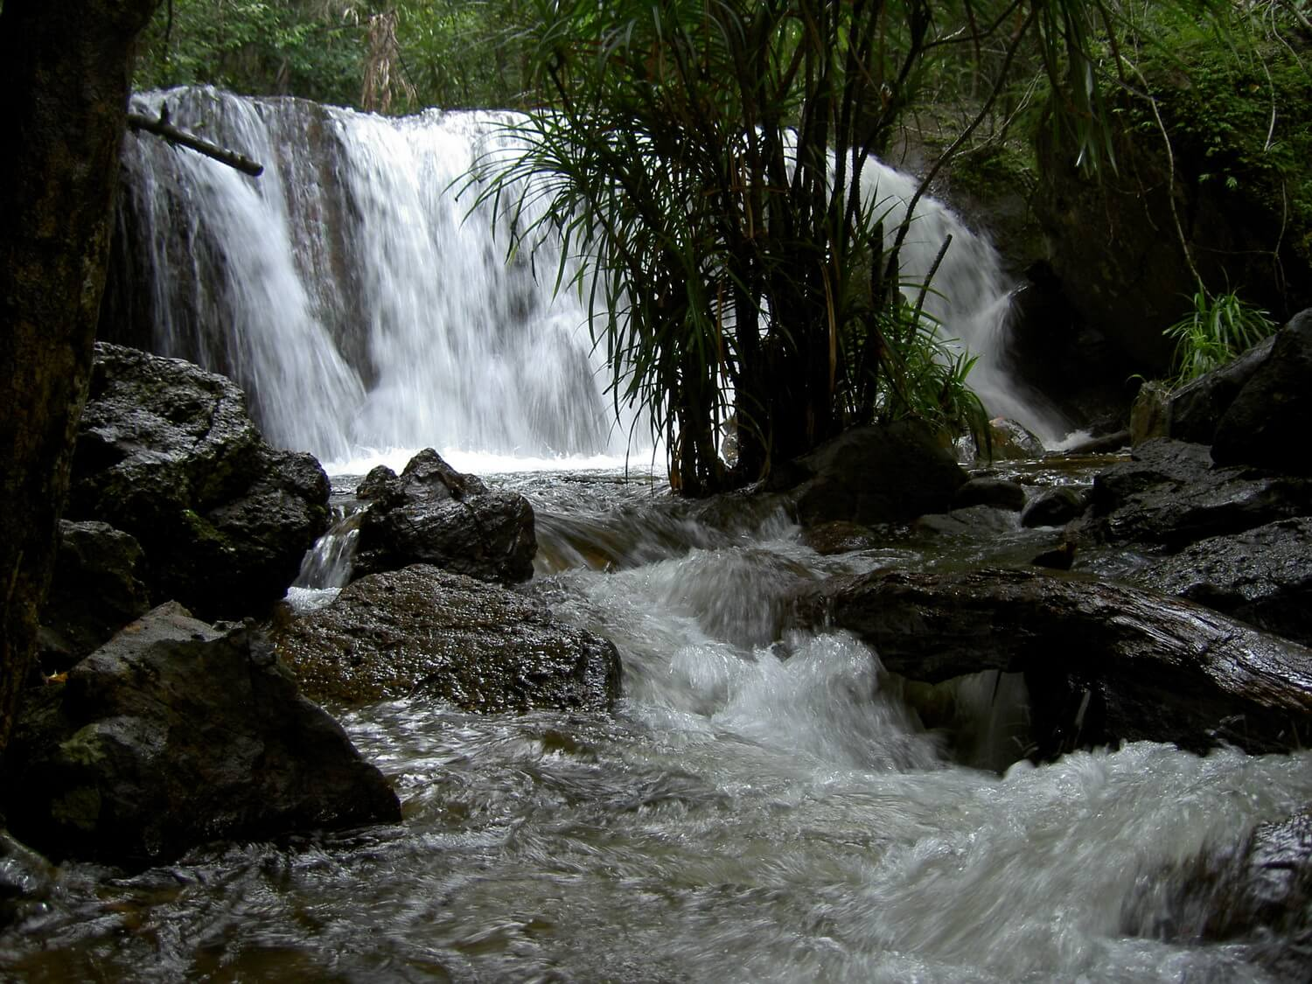

* Ham Ninh Fishing Village: where you will find a jetty that extends a couple hundred meters out to sea to allow for the shallow waters along the coast and village is predominantly involved in fishing that provide an excellent source of seafood.

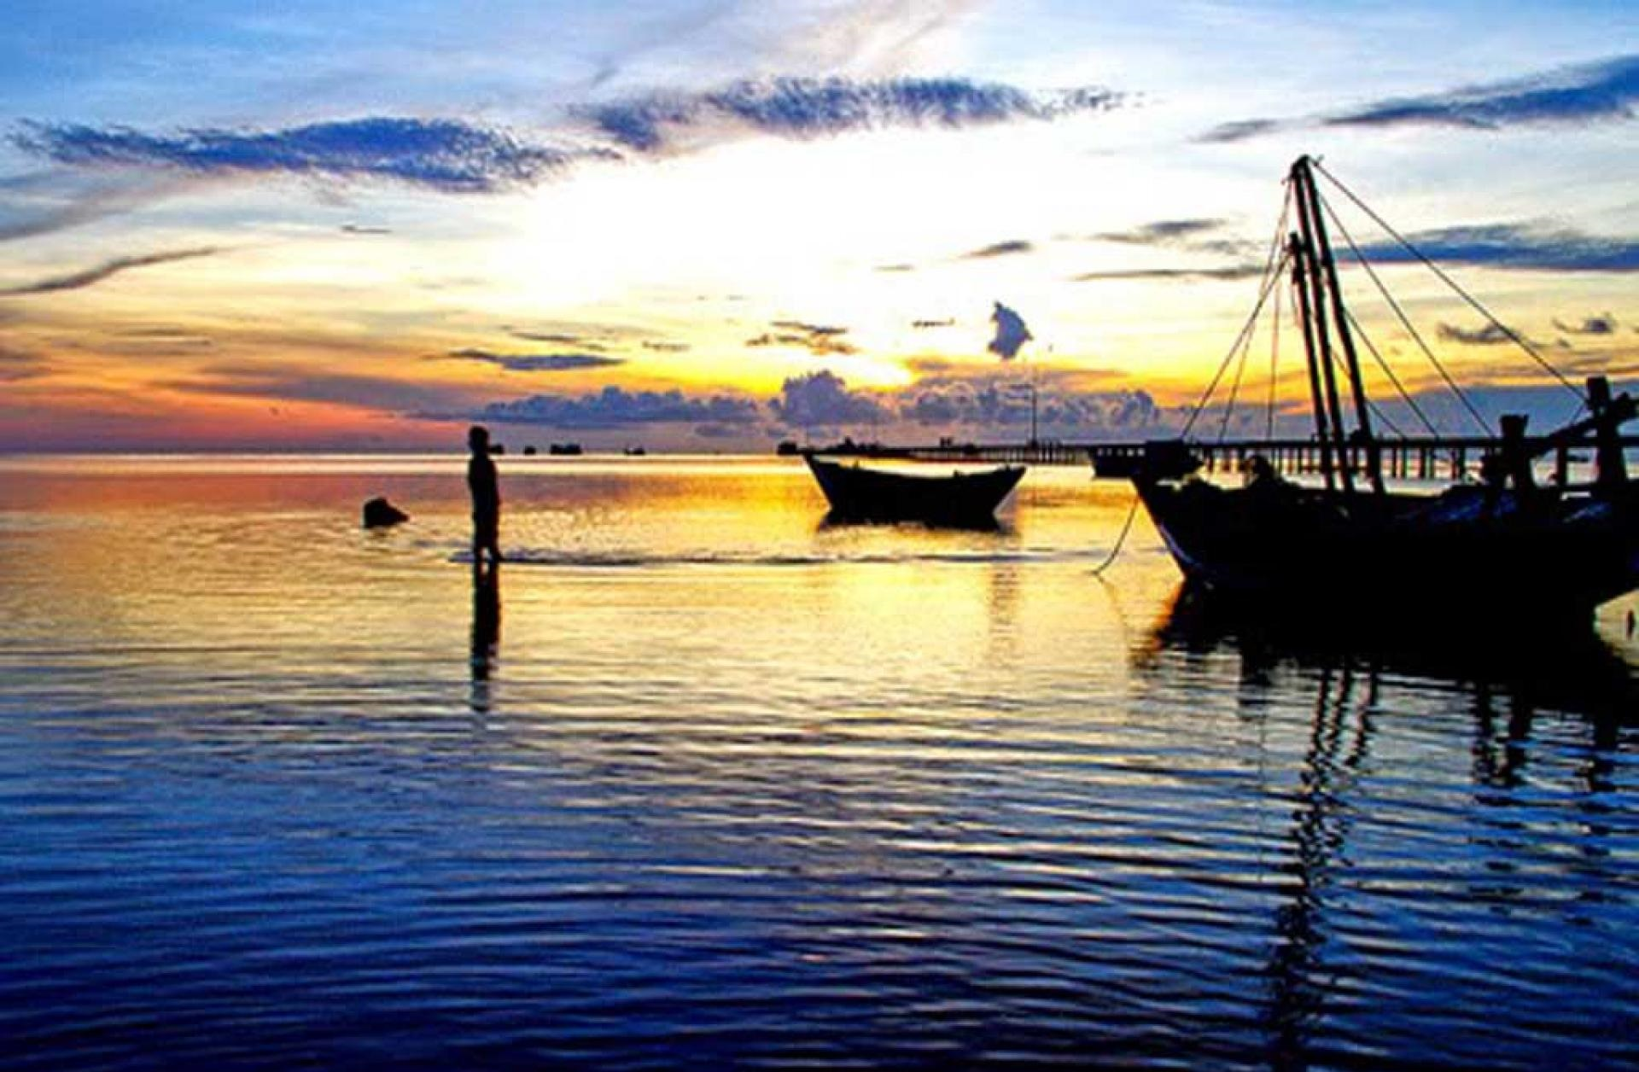

* Pepper Farm: Visit local pepper garden & meet the family who introduce about the harvesting of pepper – that is use around the world in everyone kitchen.

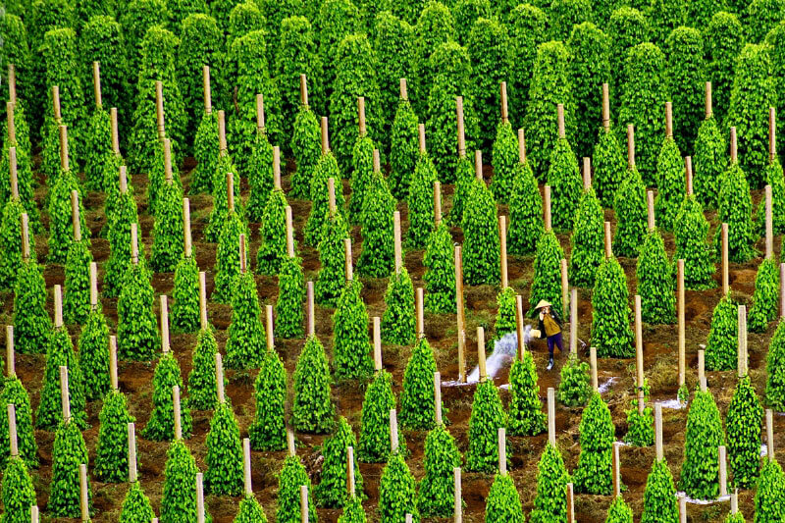

**12:00 PM:** Back to restaurant to have lunch and relax.

**Afternoon:** Check in hotel and relax.

**18:00 PM:** Back to restaurant to have dinner.

|  |  |
| --- | --- |
|  |  |
|  | |

|  |  |
| --- | --- |
|  | Sightseeing – Snokerling - Fishing |

**7:30 – 8:30 AM:** Have breakfast at the hotel.

**9:00 AM:** Depart the hotel with our tour guide.

* Pearl Farm: “Experience the beauty and allure of pearls which across centuries and cultures have long been associated with wealth, royalty and glamour”. The place you can find out procedures of pearl production.

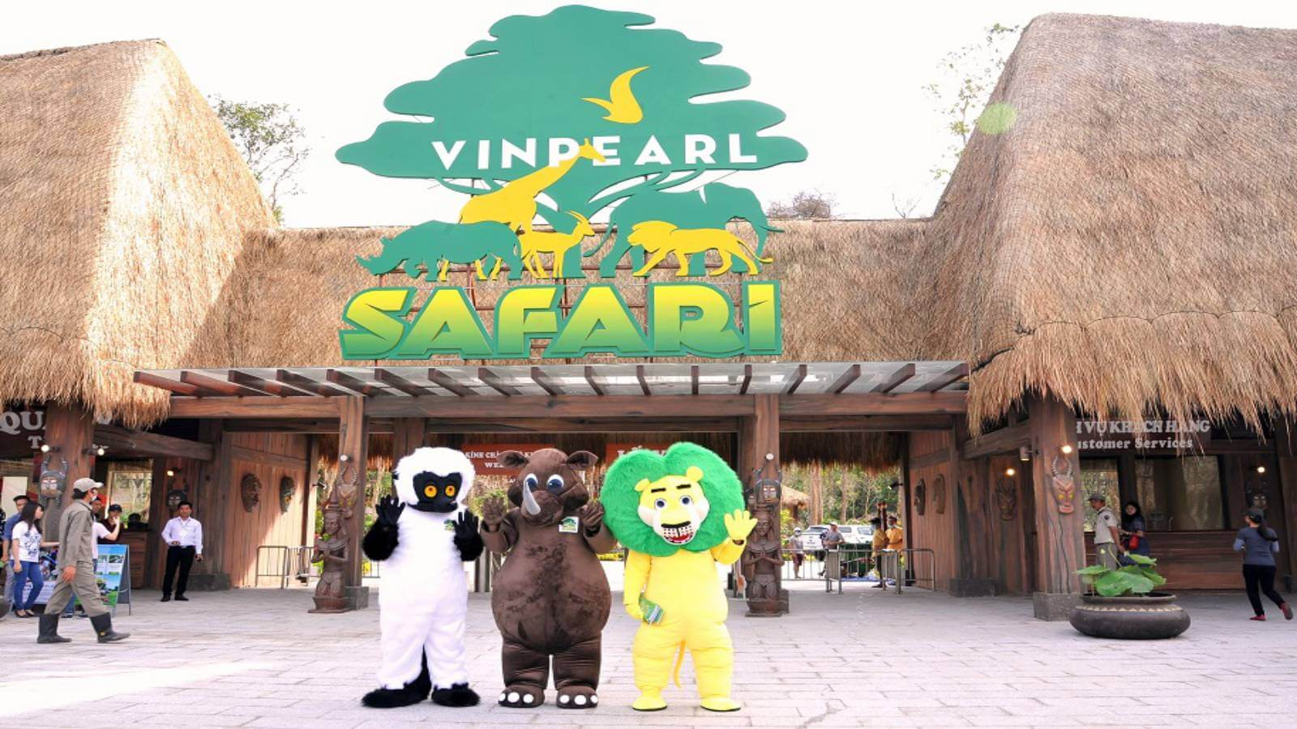

* Phu Quoc Prison : is a prison in Phú Quốc, southern Vietnam (today it is in Kiên Giang Province. The prison was built in 1949-1950 by the French colonists to jail those considered specially dangerous to the colonist government. Many of the high ranking leaders of Vietnam were detained here. It is ranked a special historical relic of national importance by the government of Vietnam. The most famous site in this prison is “tiger’s cage” . The prison covers an area of 40,000 square metres. The prison was closed after the country united and just opened for visitors later

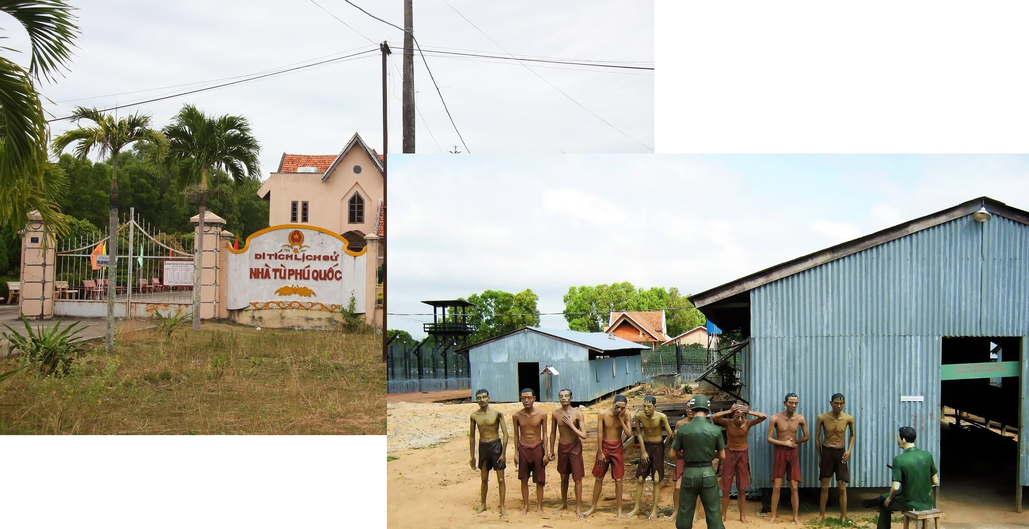

* Snorkeling & Fishing Boat Trip: Our tour guide will now take you to the harbour to meet with the boat that will take you snorkelling and fishing.ontinue on to the first of two places where you will be able to swim and snorkelling around the coral. At both stops you can also do some fishing, the boat crew will prepare any equipment needed. After the second place ,take a rest and have lunch on the boat then head back to the harbor
* Sao Beach: Its fine white sand has many fans and most of the time you can expect crystal clear turquoise water – a postcard-like example of a tropical beach

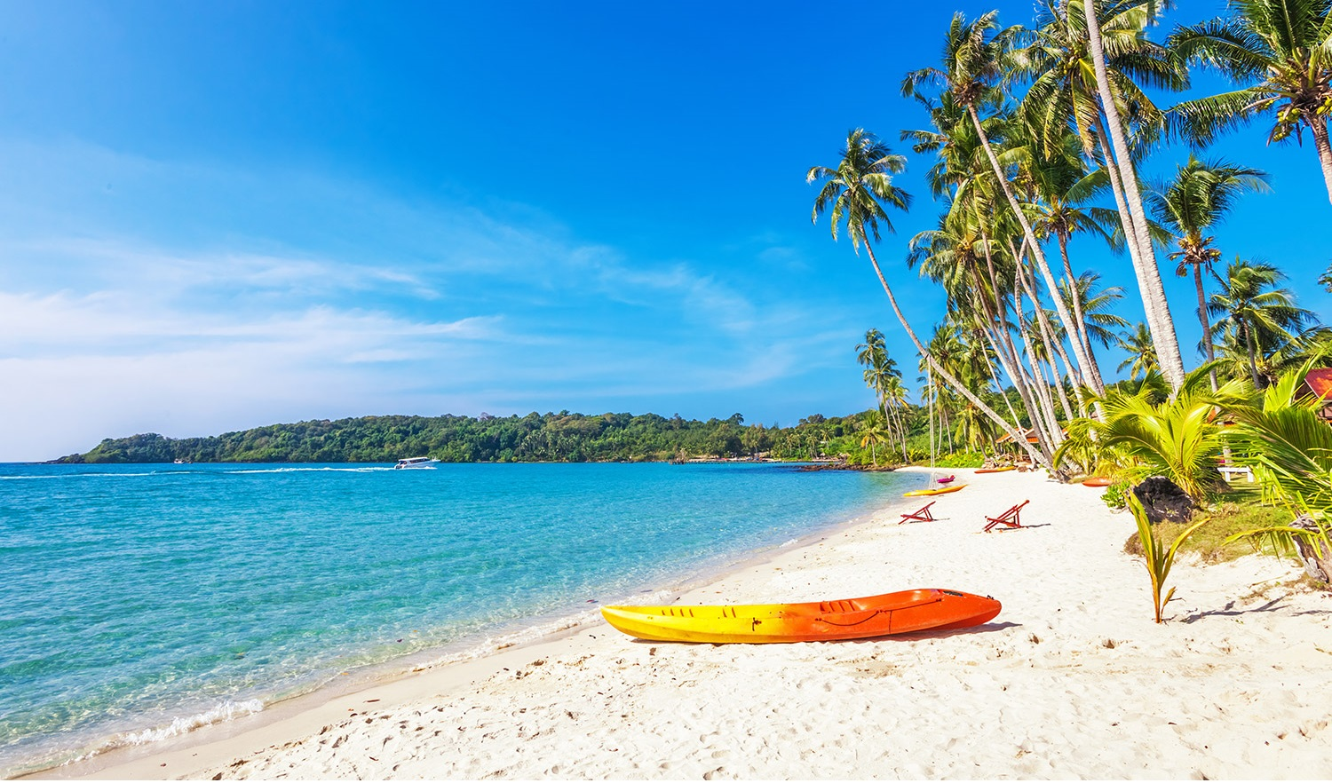

* Fish Sauce Factory: a sauce type famous on the island with name “Nước Mắm” produced from fresh fish. “Fish Sauce in the marking – The essential spices to all Vietnamese Cusines”.

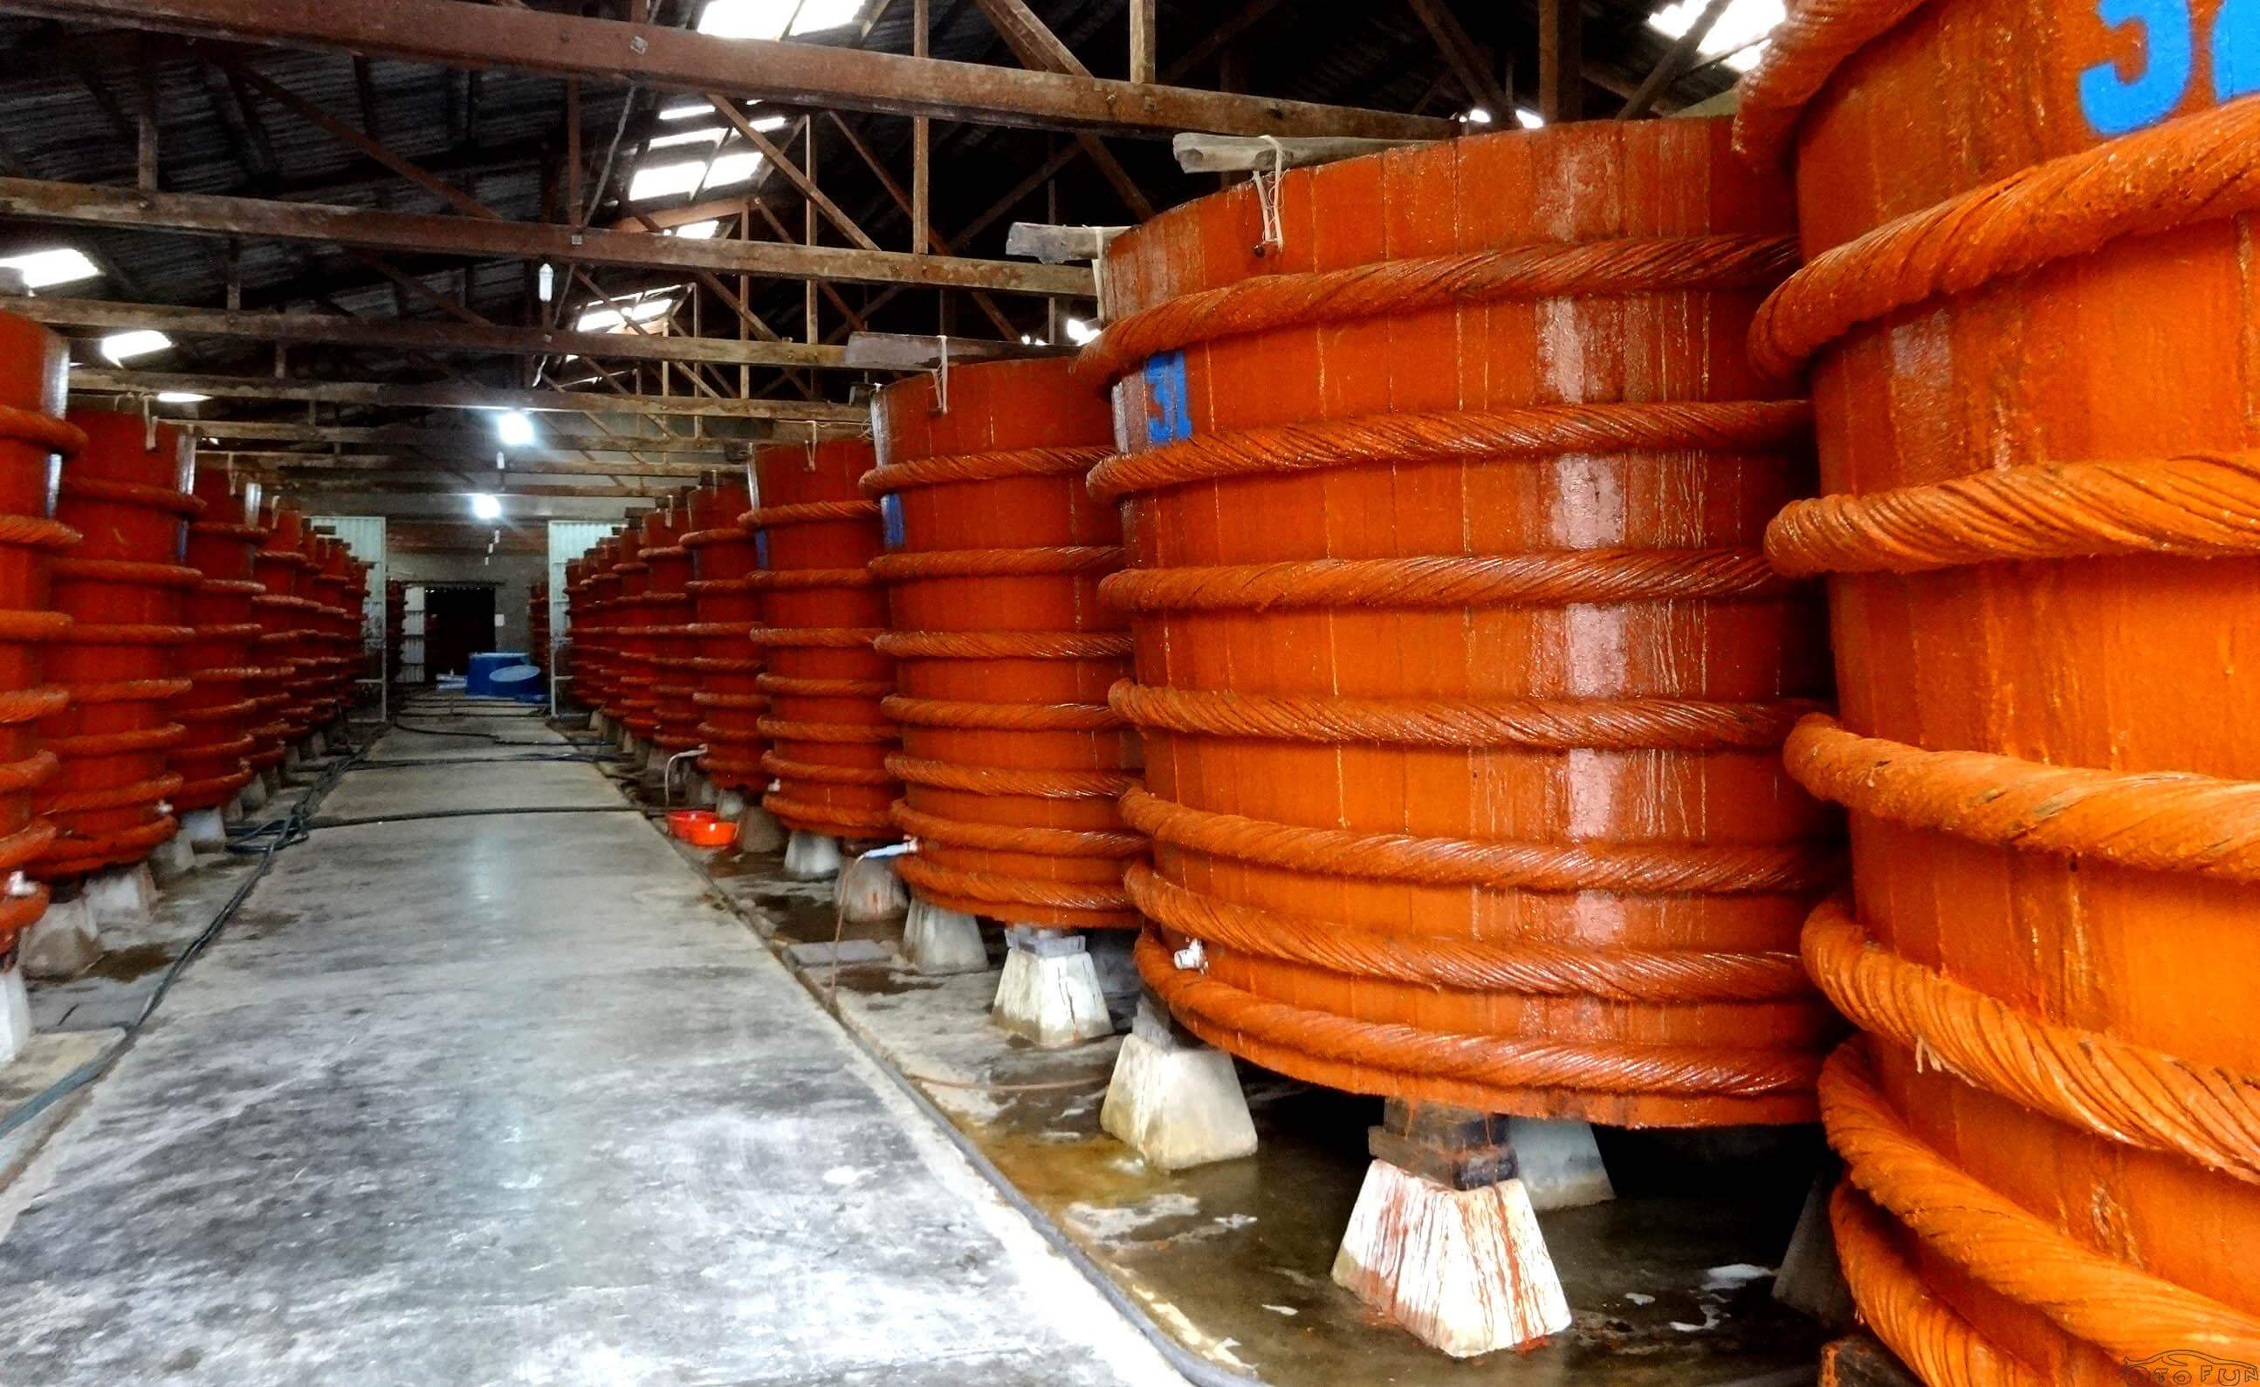

* Sim Wine: “Visit the brewer where Sim wine is produce from a gentle Rose Myrtle flower – when blossom turn into a fruit and produce into a wine”.

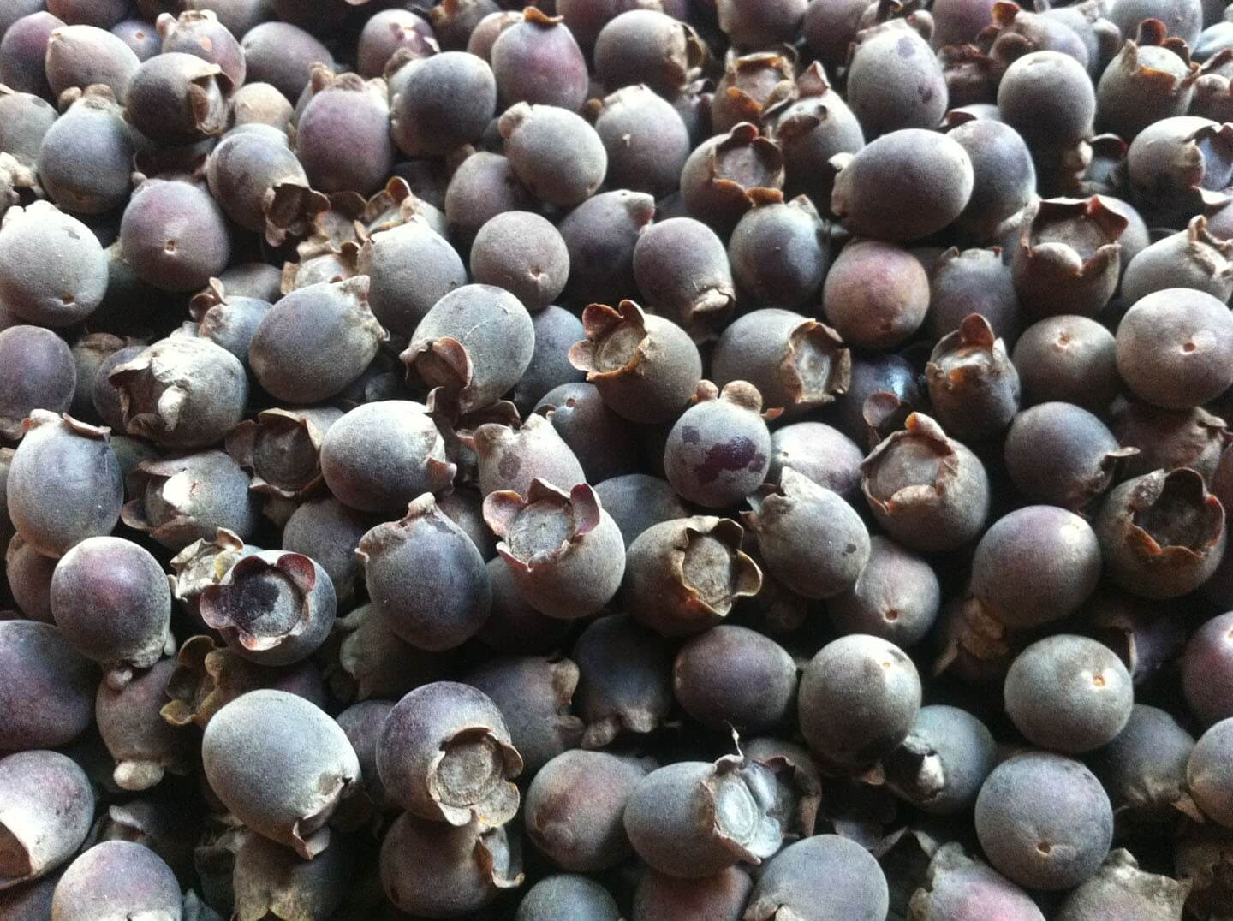

**Back to hotel:** just in time to watch the sunset.

**18:00 PM:** back to restaurant to have dinner and relax.

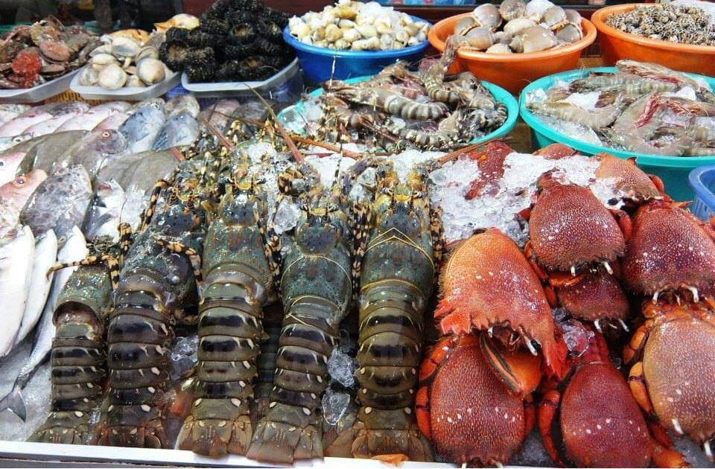

|  |  |
| --- | --- |
|  | Relax – Farewell & Goodbye |

**7:30 – 8:30 AM:** Have breakfast at the hotel.

* When ready and as your scheduled flight allows, check out of your hotel and we’ll take you to the airport in time for your flight.
* End of Tour.

